SQT CA3

Eoin Fitzsimons – X23151374

1. Implement all the required unit tests to check whether the compute method works according to expectation, namely according to the specification provided in *Question 1 A*
2. Run/execute the unit tests implemented at item *a)* and provide in your report a screenshot of the NetBeans *Test Results Window* that includes a summary of the execution of the unit tests (namely, for each unit test, the name of the test method run and whether the test has passed or failed).
3. implement a method for computing the area of a circle. Then implement the required unit test
   1. Update the test
   2. Include a screenshot of the source code corresponding to the latest version of your methods in the report.

Table of Contents

1. Unit Tests 2

2. Result of Unit Tests 3

3. Area of Circle 4

i Test code 4

ii Methods 5

# Unit Tests

/**

* Test of add method, of class Calc.

*/

@Test

public void testAdd() {

System.out.println("add");

int a = 3;

int b = 5;

int expResult = 8;

int result = Calc.add(a, b);

assertEquals(expResult, result);

}

/**

* Test of mult method, of class Calc.

*/

@Test

public void testMult() {

System.out.println("mult");

int a = 2;

int b = 3;

int expResult = 6;

int result = Calc.mult(a, b);

assertEquals(expResult, result);

}

/**

* Test of div method, of class Calc.

*/

@Test

public void testDiv() {

System.out.println("div");

int a = 100;

int b = 20;

int expResult = 5;

int result = Calc.div(a, b);

assertEquals(expResult, result);

}

/**

* Test of min method, of class Calc.

*/

@Test

public void testMin() {

System.out.println("min");

int a = 6;

int b = 5;

int expResult = 1;

int result = Calc.min(a, b);

assertEquals(expResult, result);

}

# Result of Unit Tests

Also included is the test for the area of the circle in part 3.

# Area of Circle

## i Test code

/**

* Test of carea method, of class Calc.

*/

@Test

public void testCarea() {

System.out.println("carea");

double r = 2;

double expResult = 12.56;

double result = Calc.carea(r);

assertEquals(expResult, result, 0);

// TODO review the generated test code and remove the default call to fail.

}

## ii Methods

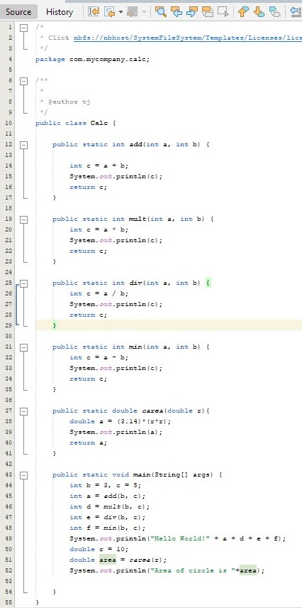

# Bibliography

**There are no sources in the current document.**